Abayomi Olujobi

Author

Excel Challenge

Kickstarter campaign report

**Three Conclusions we can draw about Kickstarter Campaigns.**

* Kickstarter is an effective way to fund your project. When looking at the total number of successful campaigns vs failed campaigns, we find that the numbers are 2185 to 1530 respectively. From these numbers, we can gather that a project funded through Kickstarter has a 58.8% chance of reaching its goal. Even when you factor in the number of canceled and live campaigns, the success rate is still at 53% while the failure rate is at 37%. Not only are Kickstarter campaigns effective, but a whopping 96% of successful campaigns exceed their targeted goal.

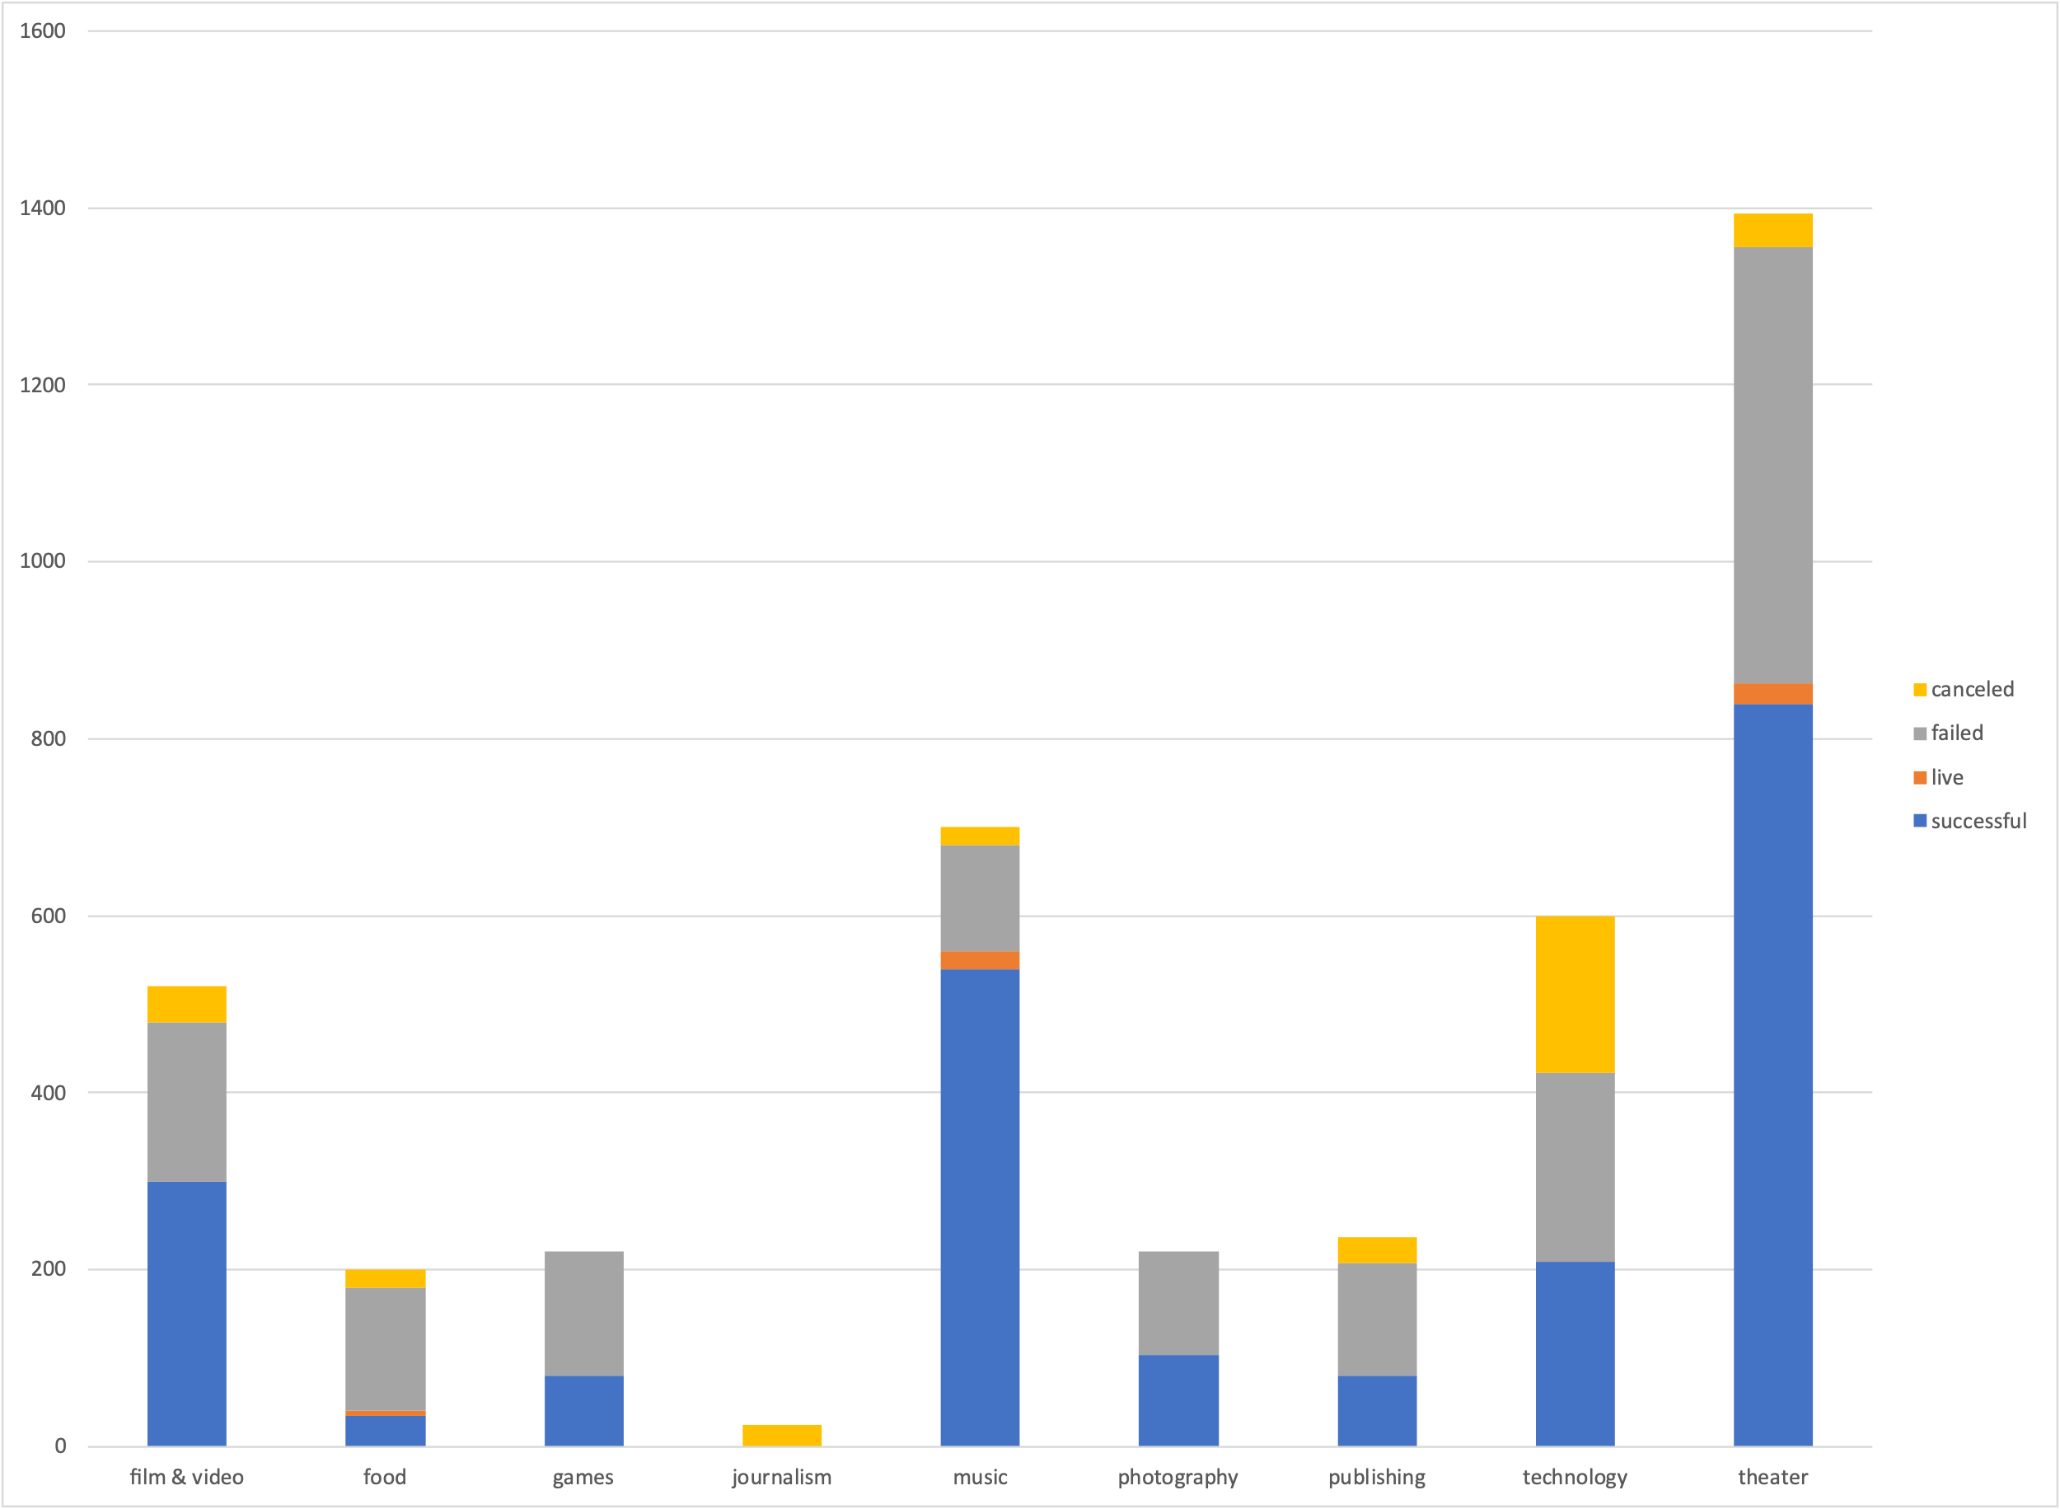

* The top three main categories of campaigns that will most likely succeed through Kickstarter are: Music, Theater, and Film and Video. First place is Music, with an overall success rate of 77%. Rock music productions in particular have a 100% success rate. Second place is Theater productions, with a 60% success rate, with Plays in particular having a 67% success rate. Also, Theater has the highest number of campaigns (33% of the grand total). Film and Video are third with a 57.6% success rate. However, Dramas and Animations are very ineffective as both have a 100% failure rate. On the flipside, the least effective and least popular category of campaign to fund through Kickstarter is Journalism which has an astounding 0% success rate and comprises of only 0.005% of the grand total of campaigns.  
    
  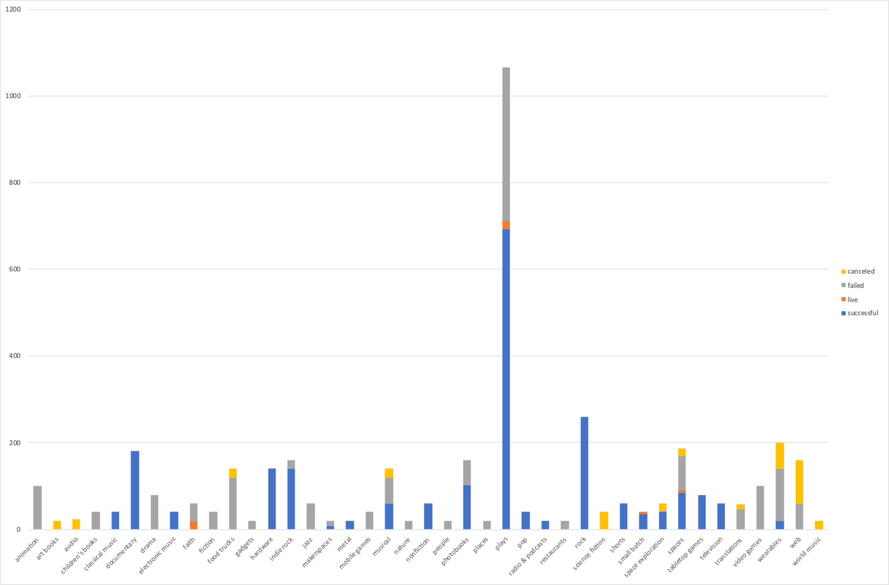
* Campaigns are most likely to succeed between February and May. The average ratio of success to failure during these months is 1.8 to 1. December, on the other hand is the worst month. The ratio of success to failure in the month of December is 0.9 to 1.   
    
  

**Limitations of this Dataset.**

* No information after the conversion date, so there is no way to tell if the successful campaigns turned any profits or were successful down the line. This information will prove useful for donors who want to know if their donation amounted into anything productive or tangible.
* 4,000 out of 300,000 projects is not enough to make an accurate analysis. A larger dataset would’ve been more effective.
* There are no data from other types of crowd-funding platforms, such as Indiegogo, Patreon or GoFundMe, to compare Kickstarter’s campaign with. Therefore, this makes it impossible to accurately calculate the effectiveness of this dataset.

**Some other possible tables and/or graphs that we could create.**

* A table and graph that compares the number of successful and failed campaigns in different countries. The table can be filtered by categories to give a better understanding of what kinds of campaigns people from different countries are most likely to donate to.
* A table and graph to chart campaign duration in relation to each category. It will be interesting to see the amount of time it took for each category to reach their goal.

**Bonus Statistical Analysis – Sheet 6**

* In my opinion, the mean number does not summarize the data meaningfully. When looking at the numbers from the successful campaigns, we see that the mean number of backers is 194 and the maximum number is 26,457; while the median is 62. The mean number is too far away from the maximum number of backers. When the mean number is too far from the maximum number, it means that the data is not normally distributed. When the mean is closer to the minimum number than it is to the maximum, then this means that the bell curve is skewed to the right. When a dataset is not normally distributed, then the median summarizes the data more meaningfully.
* The Variance number shows how spread out the data is around the mean (713,167 to 194). The higher the variance is, the more variability there is in the dataset.